Database Management Systems

Project Documentation: **Class Diagrams and Use Case Analysis**

**Submitted by : Sangeetha Sivaramakrishnan NUID:001771893 Mail-Id:** [**sivaramakrishnan.s@husky.neu.edu**](mailto:sivaramakrishnan.s@husky.neu.edu)

**Batch : Spring 2015**

**BLOOD DONORS HUB**

**DESCRIPTION (Problem statement with Solution)**

SCOPE

The system facilitates a web based application where the employee can donate blood or request for blood.

DESCRIPTION

· All employees must register to the application giving their personal details such as Name, City, Age, Blood Group, Email-ID and Phone Number.

· The person in need of blood i.e the other employee can just login and post his requirements which would be the blood group needed and the quantity of blood required.

· To keep track of the last date of donation per person to ensure that he does not receive any mail or message for three months from the date of donation.

· The person who has donated blood for the most number of times per year will be awarded by the company.

TECHNICAL ASPECTS

· For developing web application- ASP.NET, MVC/WEB forms.

· For the User Notification System- SMTP and Socket Programming.

· Database Management for users.

· Authentication.

**USE CASE ANALYSIS**

**Use Case I :** Create the Application UI.

Description:

The main Purpose of the Use case is to develop the look and feel of the Application.

The Page Contains Links to Social Media Accounts as well.

**Use Case II :** Implement Registration UI and Log In UI

Description:

This is the UI to enable New Users to register themselves and registered users to Log in to the application.

**Use Case III :** Create The Database with required tables

Description:

Create The database with the tables as required.

**Use Case IV :** Create the Data Access and Business Layer.

Description:

Code to connect to the created Database as I will be using the Database first approach.

The data access layer will contain the code to connect to the database along with sql queries to access the available data.

**Use Case V :** Register New Users and Allow Log in Access to registered Users

Description:

Allow New users to register themselves through the generated UI and allow access to registered Users through Authentication of valid users

**Use Case VI :** Logged In Users Post Requests. Email Sent out to all eligible Users with matching blood types

Description:

Socket programming implemented here for sending emails to eligible users. Eligibility check is also to be made.

**A few Screenshots of UIs**

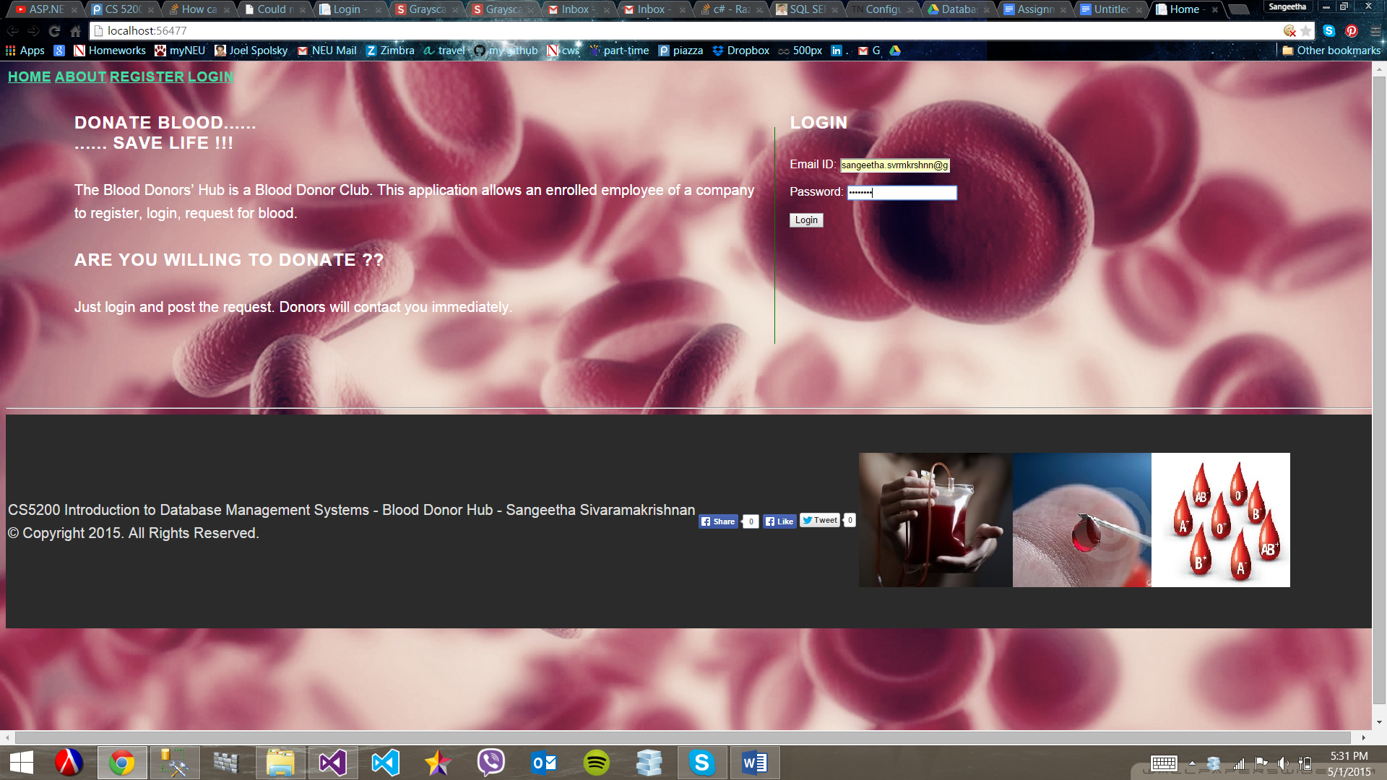**The Main UI**

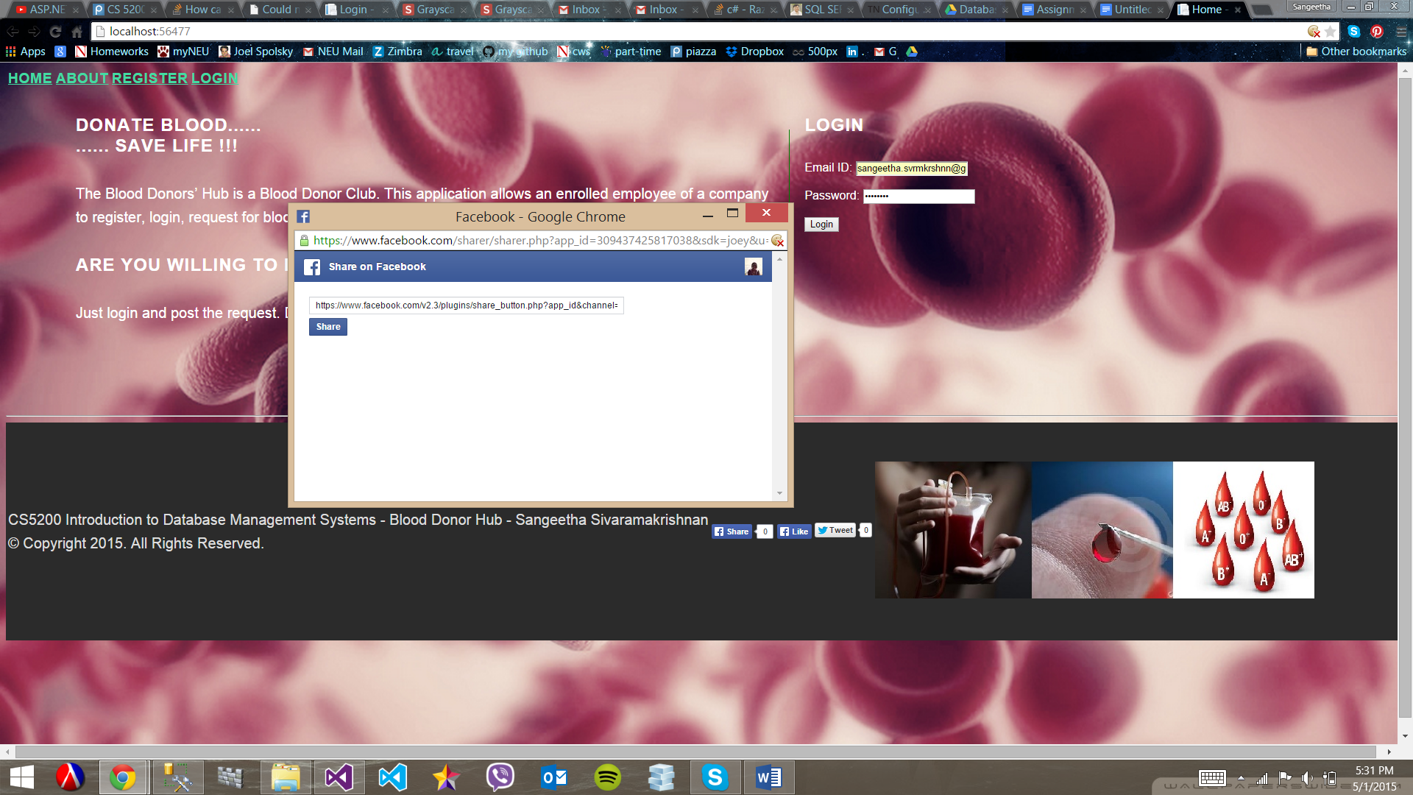**Sharing page on Facebook**

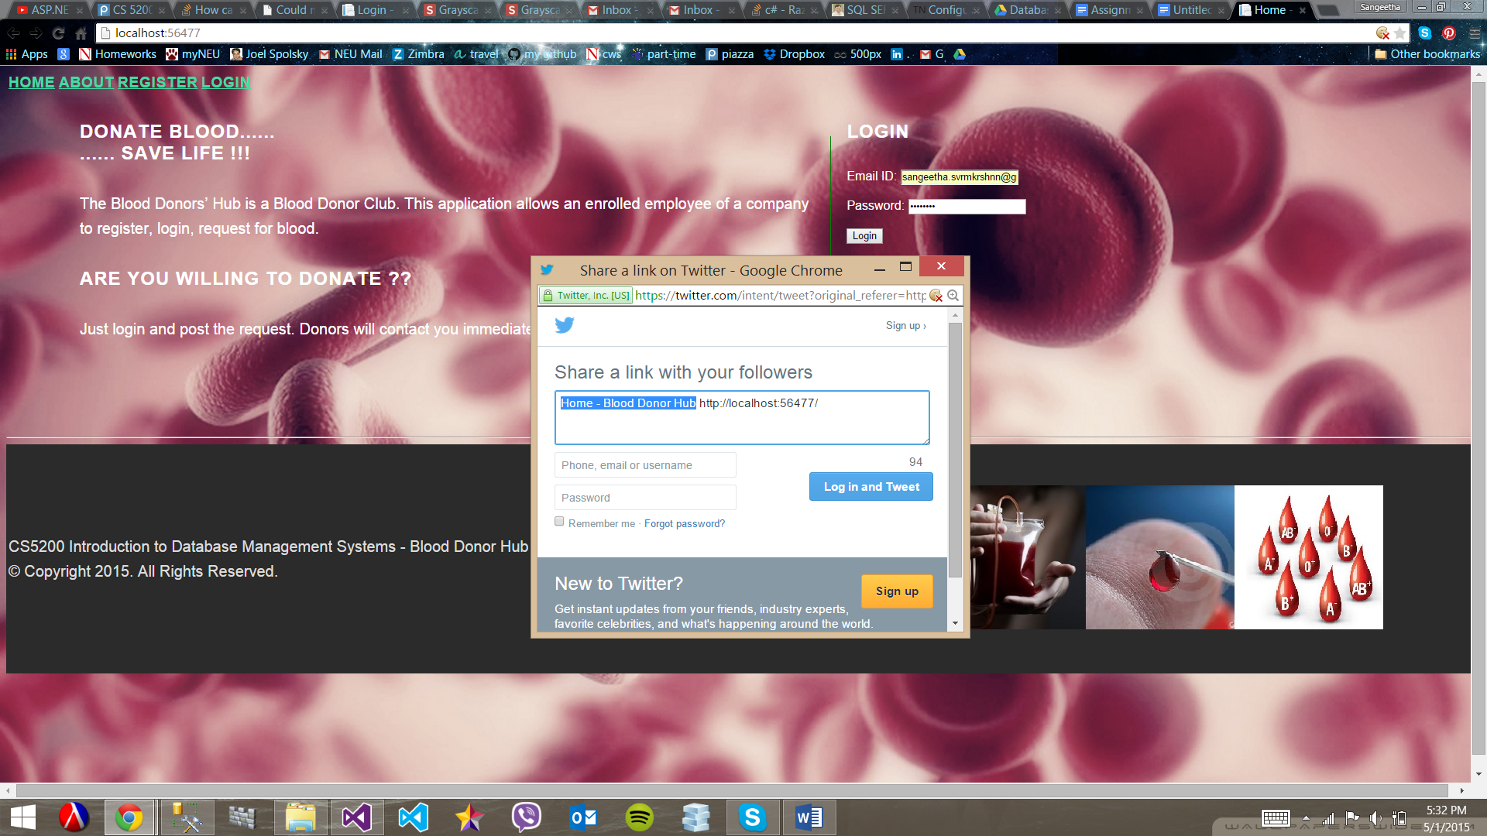**Sharing through twitter**

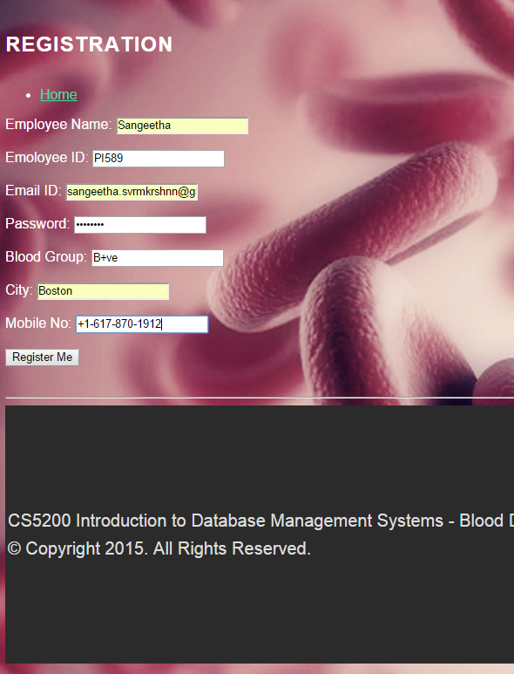 **The registration UI**

**CLASS DESIGN**

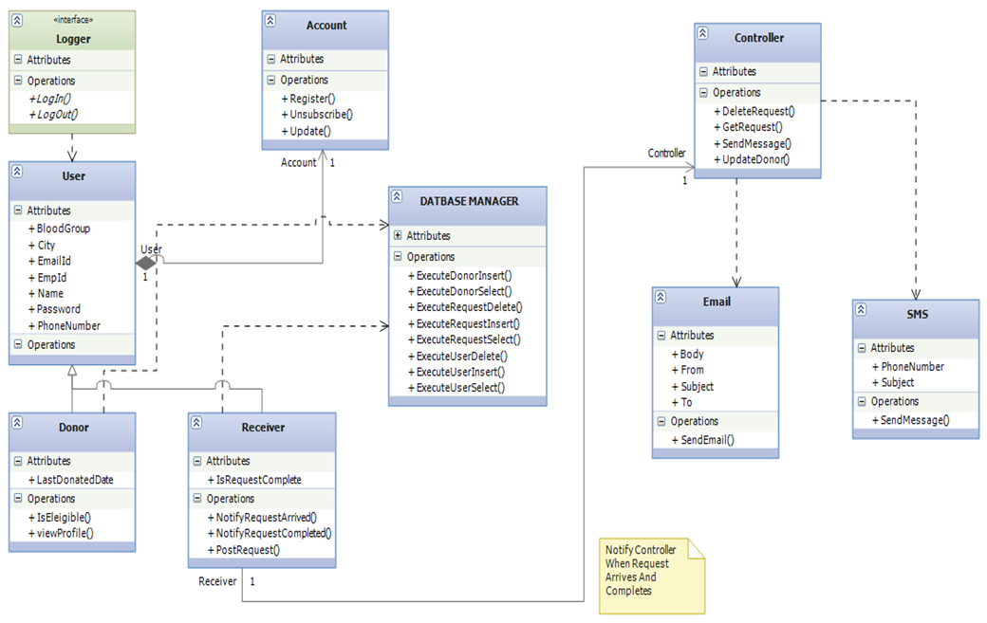

**LAYER ARCHITECTURE**

